MS SQL SERVER PROJECT

Indian_summer_products

SQL Problems & Solutions

**Description:** This project focuses on analysing **Indian summer skincare and personal care products** using MS SQL.

The objective of this project is to **gain insights into market trends, consumer preferences, and product performance** by leveraging SQL queries for structured data analysis. Key analyses include:

* Identifying **popular products** based on ratings and usage frequency.
* Analyzing the impact of **SPF ratings, organic ingredients, and paraben-free claims** on product popularity.
* Understanding **regional usage patterns** and online availability trends.
* Categorizing products based on **age groups, gender, and skin type suitability**.

**Data:** [Dataset](https://drive.google.com/file/d/1GcoFu84u885XQX8h9RXu1RhK3eG8JE_n/view?usp=sharing)

**Tool:** SQL Server Management Studio

**Analysis Technique:** MS SQL Queries

-- Creating schema and table

**CREATE DATABASE IF NOT EXISTS** ecommerce;

**USE** ecommerce;

**CREATE TABLE** Indian_summer_products(

Product_id money NOT NULL PRIMARY KEY,

Product_name nvarchar(50) NOT NULL,

Category nvarchar(50) NOT NULL,

Brand nvarchar(50) NOT NULL,

Average_price FLOAT NOT NULL,

SPF_rating tinyint NOT NULL,

Skin_type nvarchar(50) NOT NULL,

Age_group nvarchar(50) NOT NULL,

Gender nvarchar(50) NOT NULL,

Popularity_rating tinyint NOT NULL,

Usage_frequent nvarchar(50) NOT NULL,

Primary_Ingredient nvarchar(50) NOT NULL,

Organic bit NOT NULL,

Paraben_free bit NOT NULL,

Region_usage nvarchar(50) NOT NULL,

Online_availability nvarchar(50) NOT NULL

);

**1. Select only the Product_Name, Category, and Average_Price of products.**

SELECT product_name, category, average_price

FROM indian_summer_products;

**Output:**

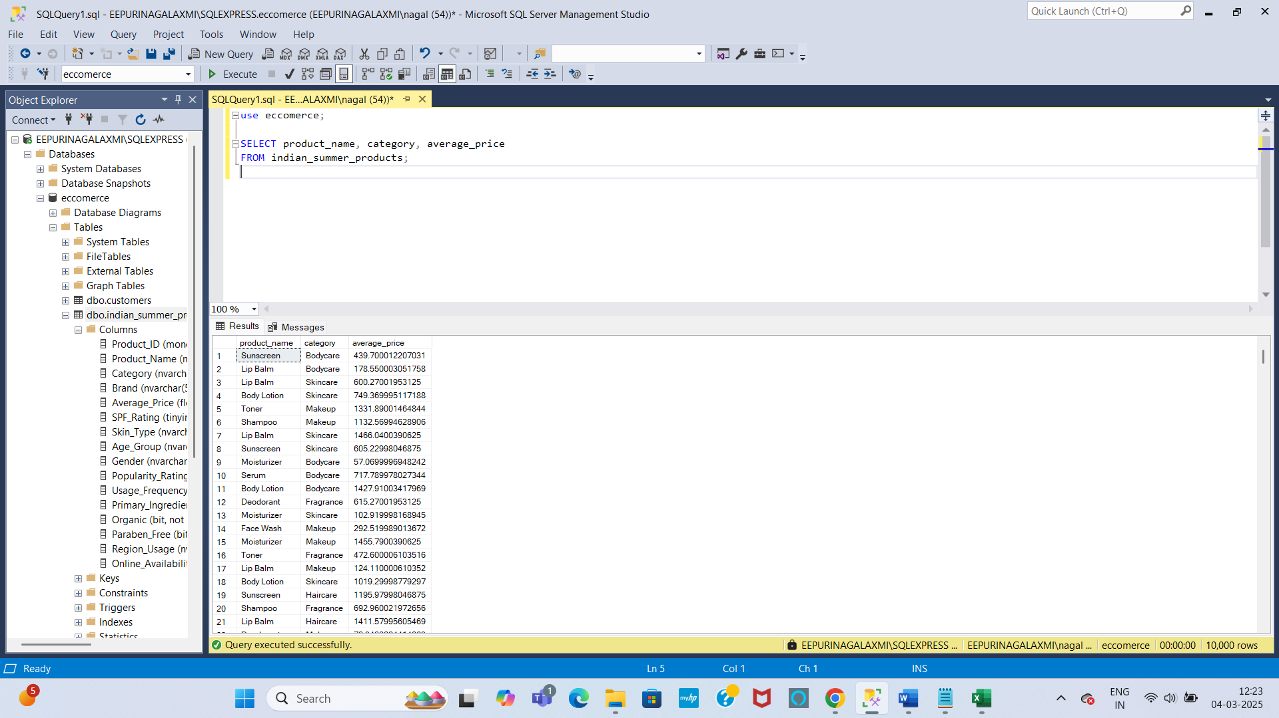

**2. Find all products that belong to the "Skincare" or “Makeup” category.**

SELECT * FROM indian_summer_products

WHERE Category IN ('skincare', 'makeup');

**Output:**

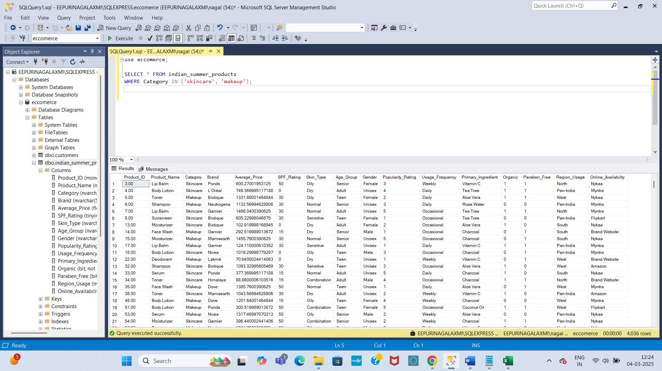

**3. Retrieve all products with an SPF_Rating greater than 30.**

SELECT * FROM indian_summer_products

WHERE SPF_Rating >30;

**Output:**

s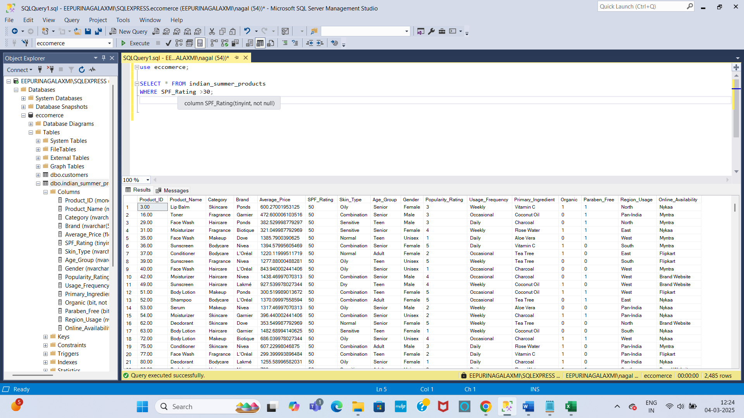

**4. List distinct Skin_Types available in the table.**

SELECT DISTINCT skin_type FROM indian_summer_products;

**Output:**

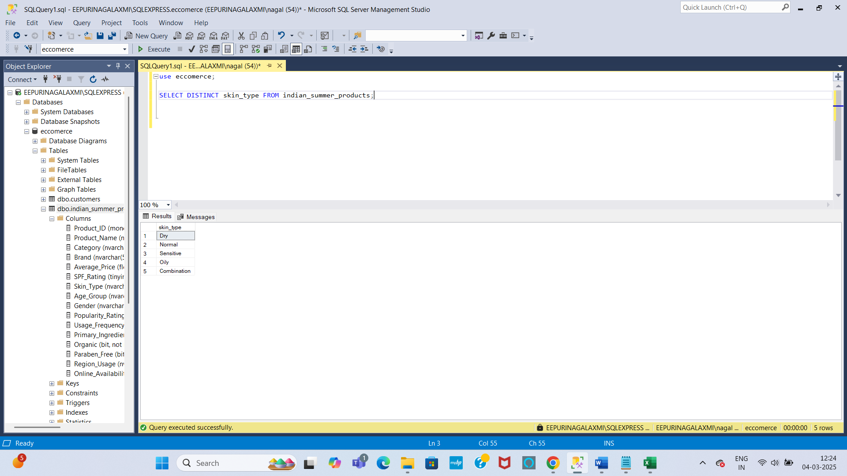

**5. Retrieve all Organic products sorted by Popularity_Rating in descending order.**

True = 1, False =0

SELECT * FROM indian_summer_products

WHERE organic=1

ORDER BY Popularity_Rating desc;

**Output:**

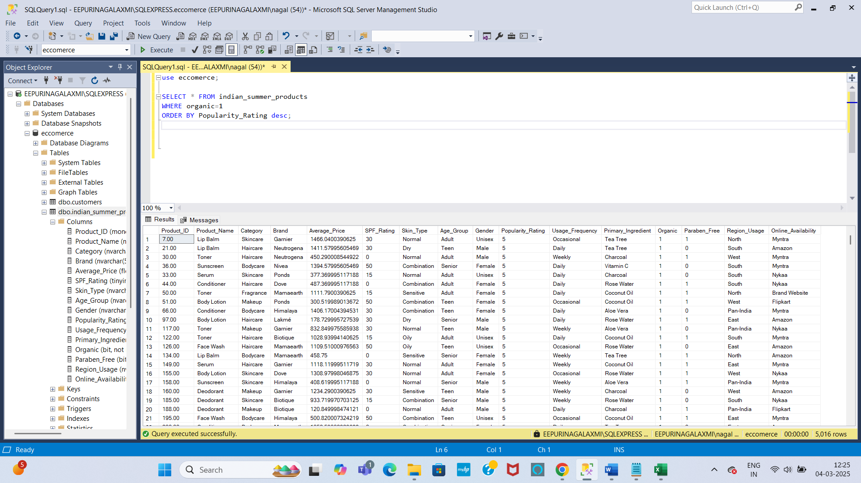

**6. Get all Paraben_Free products that are available on any online platform (Amazon, Nykaa, Myntra).**

SELECT * FROM indian_summer_products

WHERE PARABEN_FREE = 1 AND online_availability IN ('Amazon', 'nykaa', 'myntra’);

**Output:**

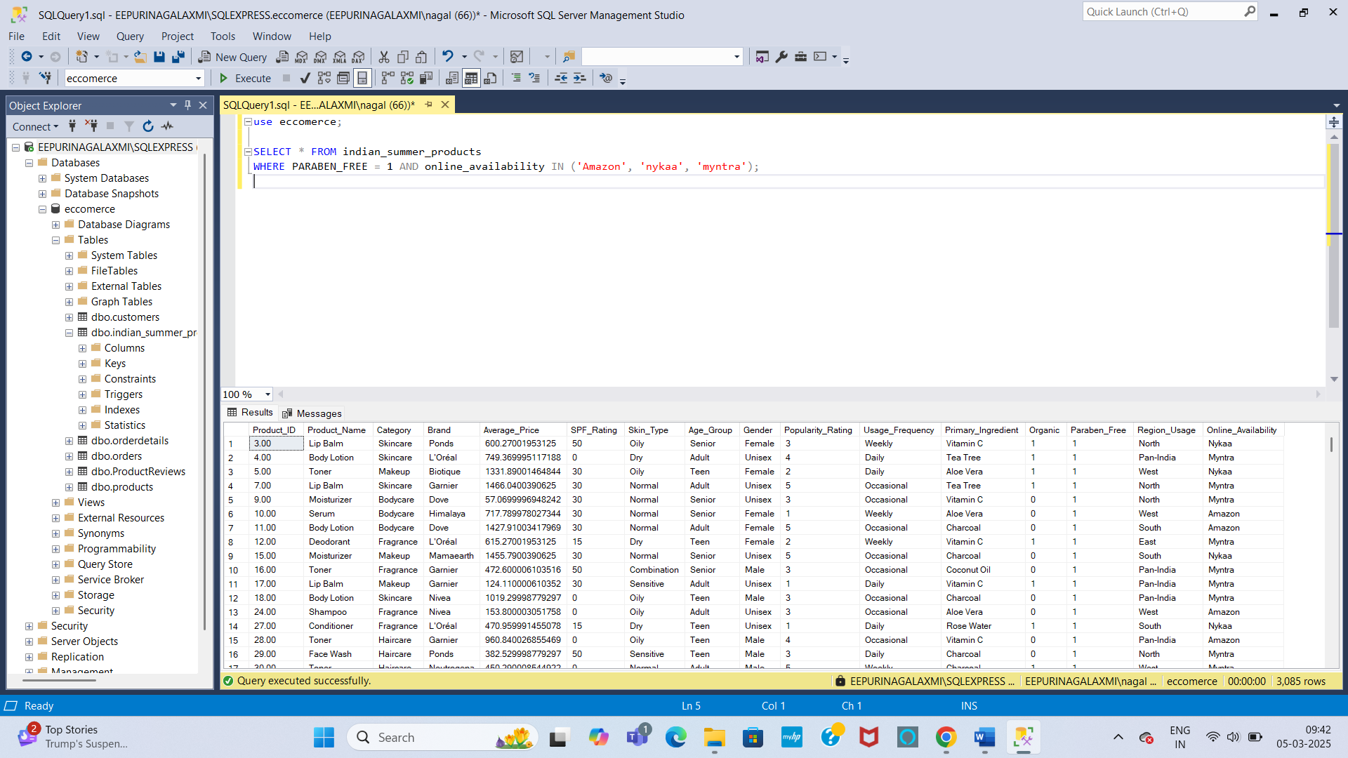

**7. Find all products that have an Average_Price between 500 and 1000.**

SELECT * FROM indian_summer_products

WHERE Average_Price BETWEEN 500 AND 1000;

**Output:**

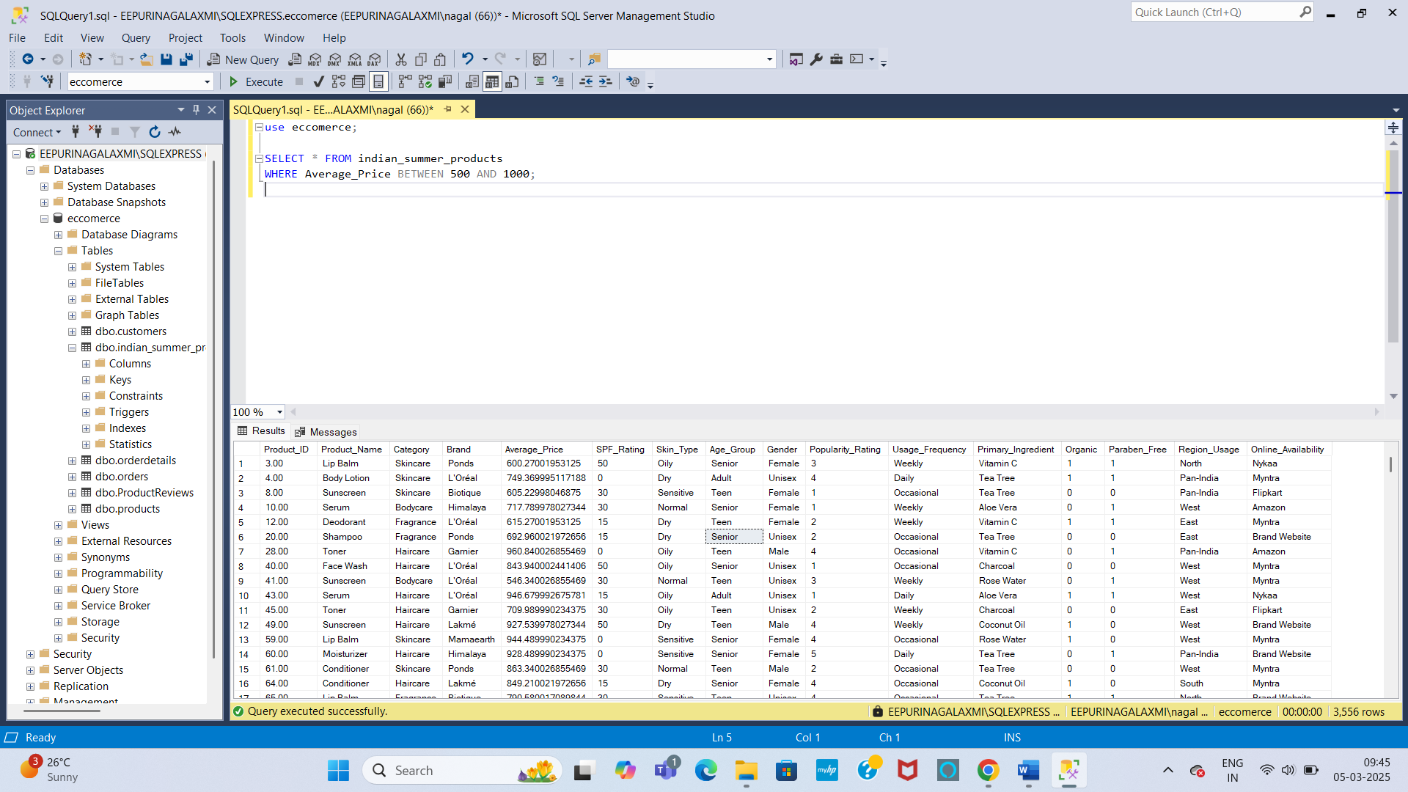

**8. Display products used in the "South" region and order them by Usage_Frequency.**

SELECT * FROM indian_summer_products

WHERE Region_usage = 'south'

ORDER BY usage_frequency;

**Output:**

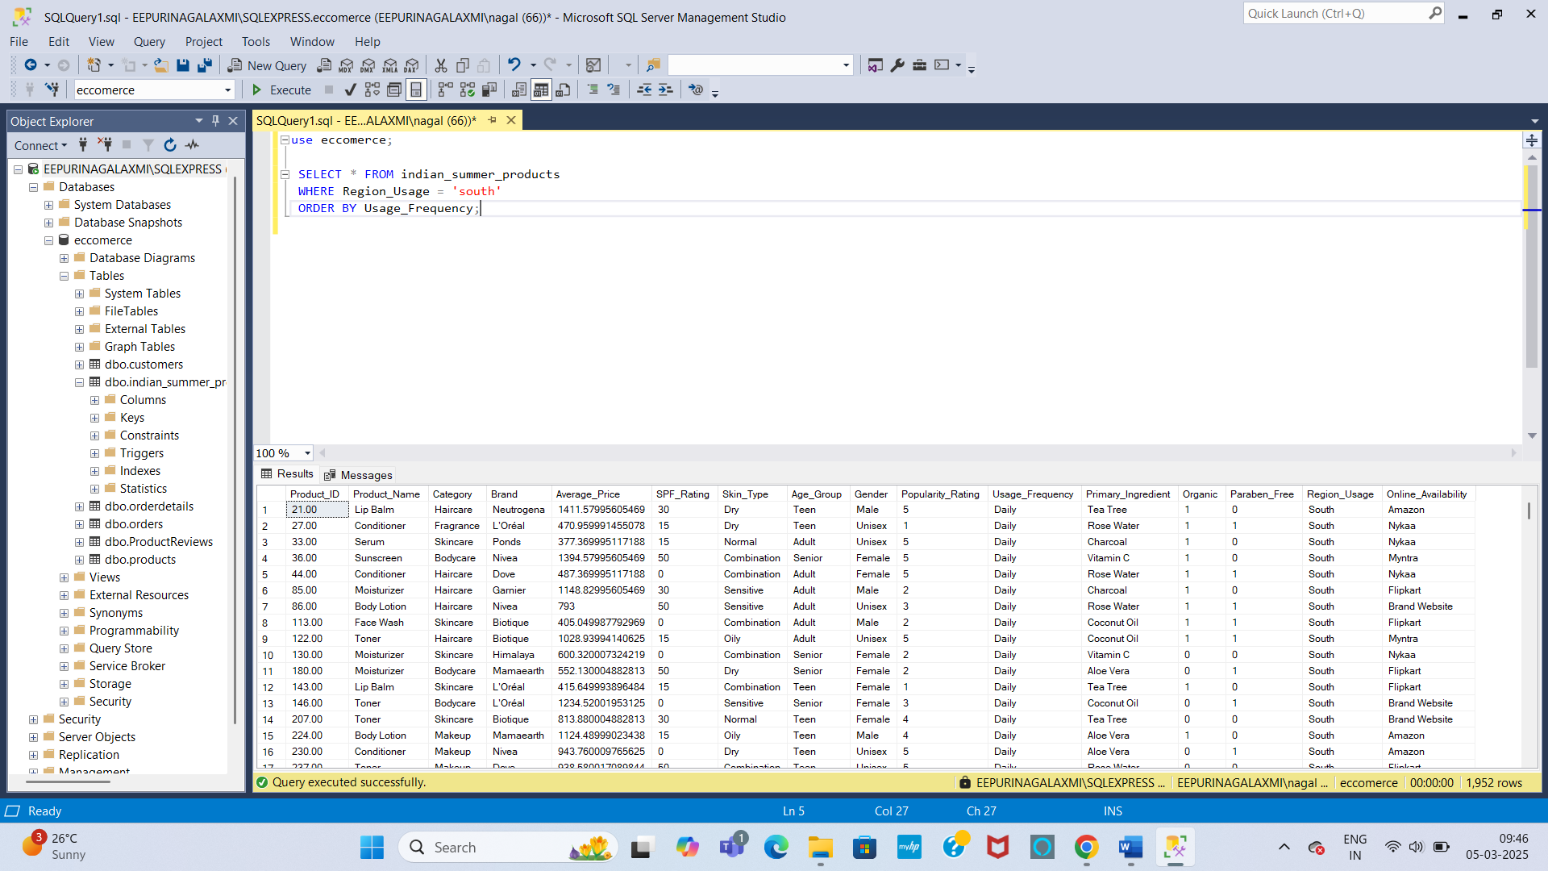

**9. Retrieve products used by females and sorted by Age_Group.**

SELECT * FROM indian_summer_products

WHERE gender = 'female'

ORDER BY age_group;

**Output:**

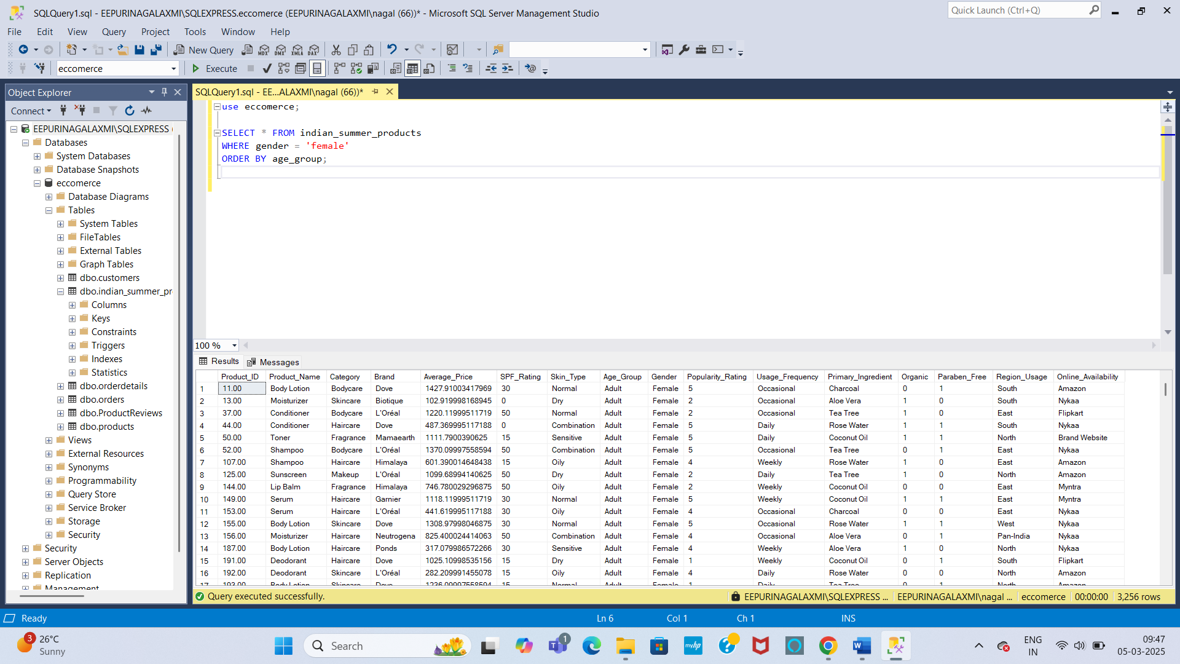

**10. Find the average price of all Garnier products.**

SELECT brand, AVG(average_price) AS avg_price FROM indian_summer_products

WHERE brand = 'garnier'

GROUP BY brand;

**Output:**

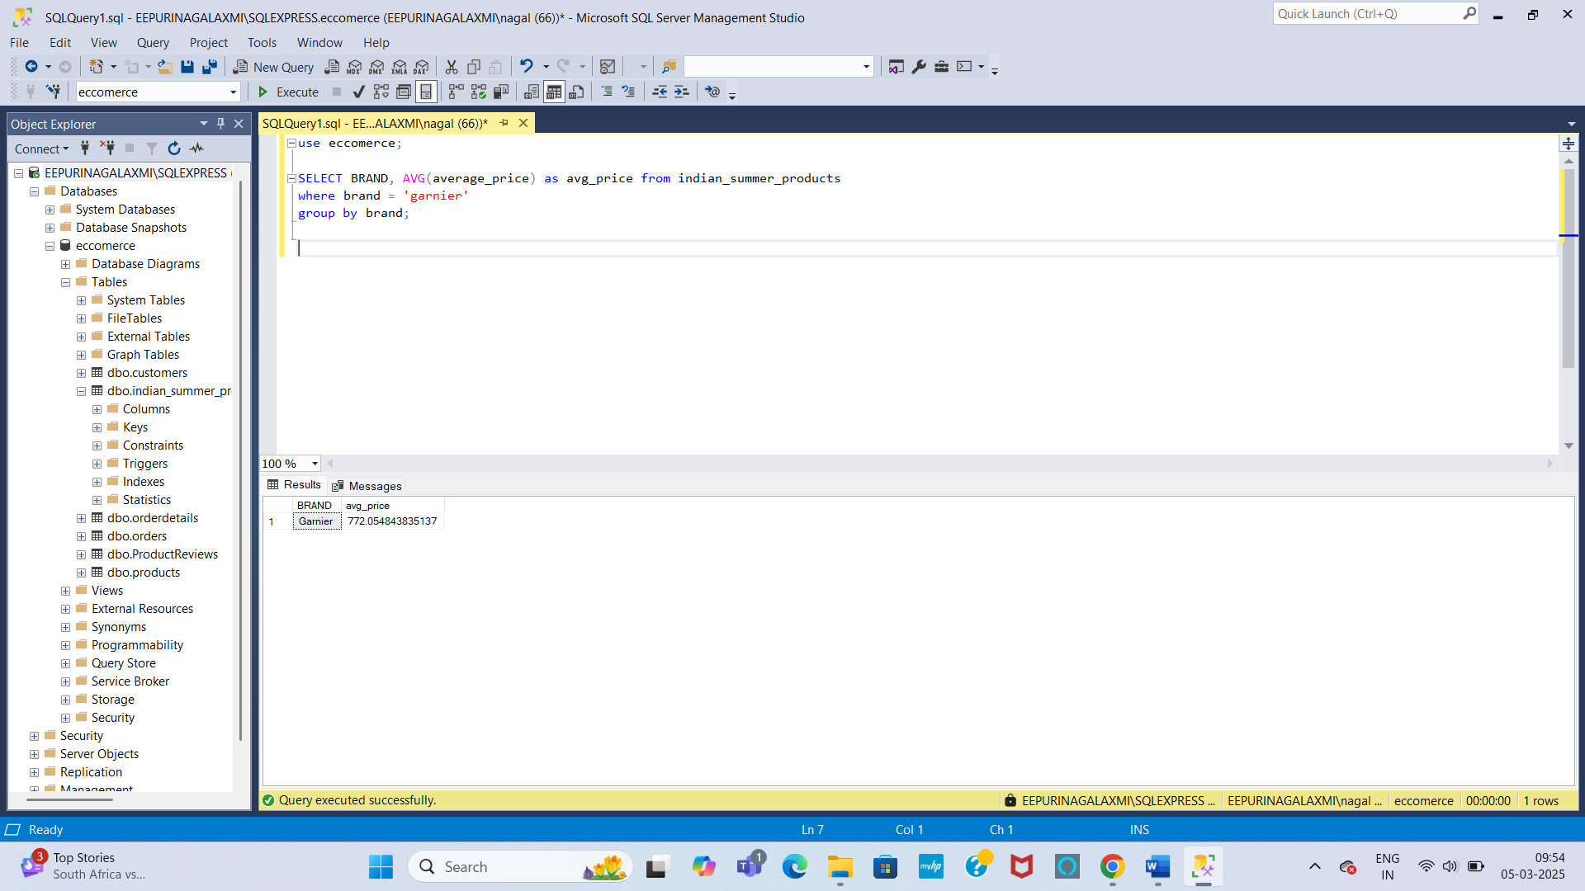

**11. Count the number of products available for "Oily" skin.**

SELECT skin_type, COUNT(*) AS available_products FROM indian_summer_products

WHERE skin_type = 'Oily'

GROUP BY skin_type;

**Output:**

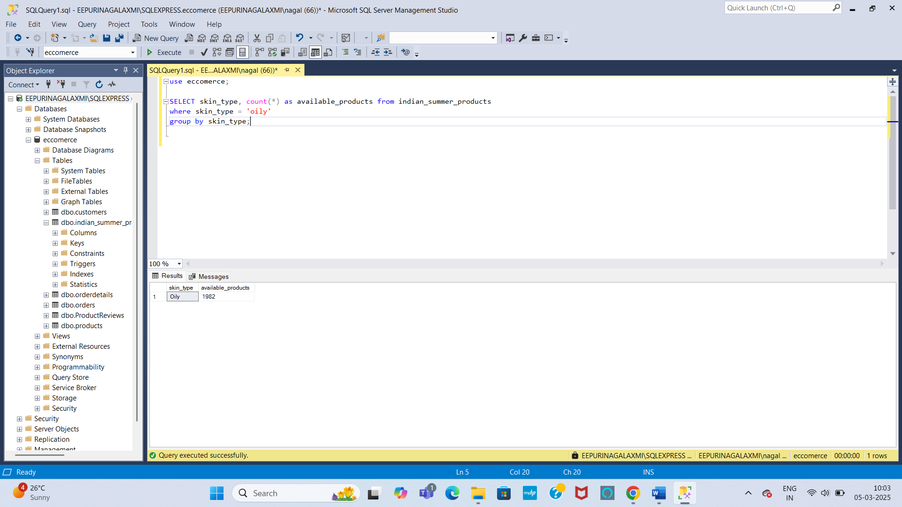

**12. Get the highest Popularity_Rating for each Brand.**

SELECT Brand, MAX(popularity_rating) AS highest_popularity_rating

FROM indian_summer_products

GROUP BY brand;

**Output:**

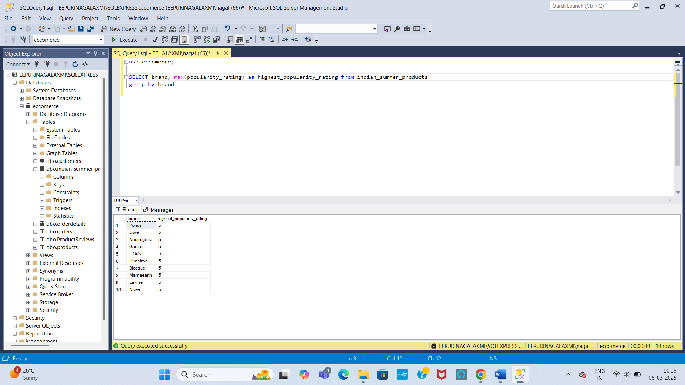

**13. Find out how many products are Organic and how many are Non-Organic.**

SELECT Organic, COUNT(*) AS no_of_products FROM indian_summer_products

GROUP BY organic;

**Output:**

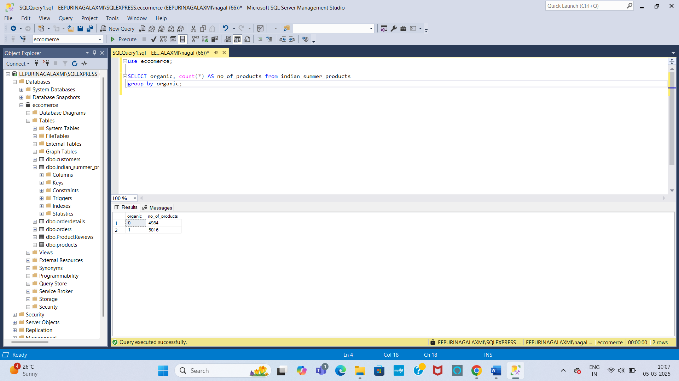

**14. Display the total number of products in each Age_Group.**

SELECT Age_group, COUNT(*) AS no_of_products FROM indian_summer_products

GROUP BY Age_group;

**Output:**

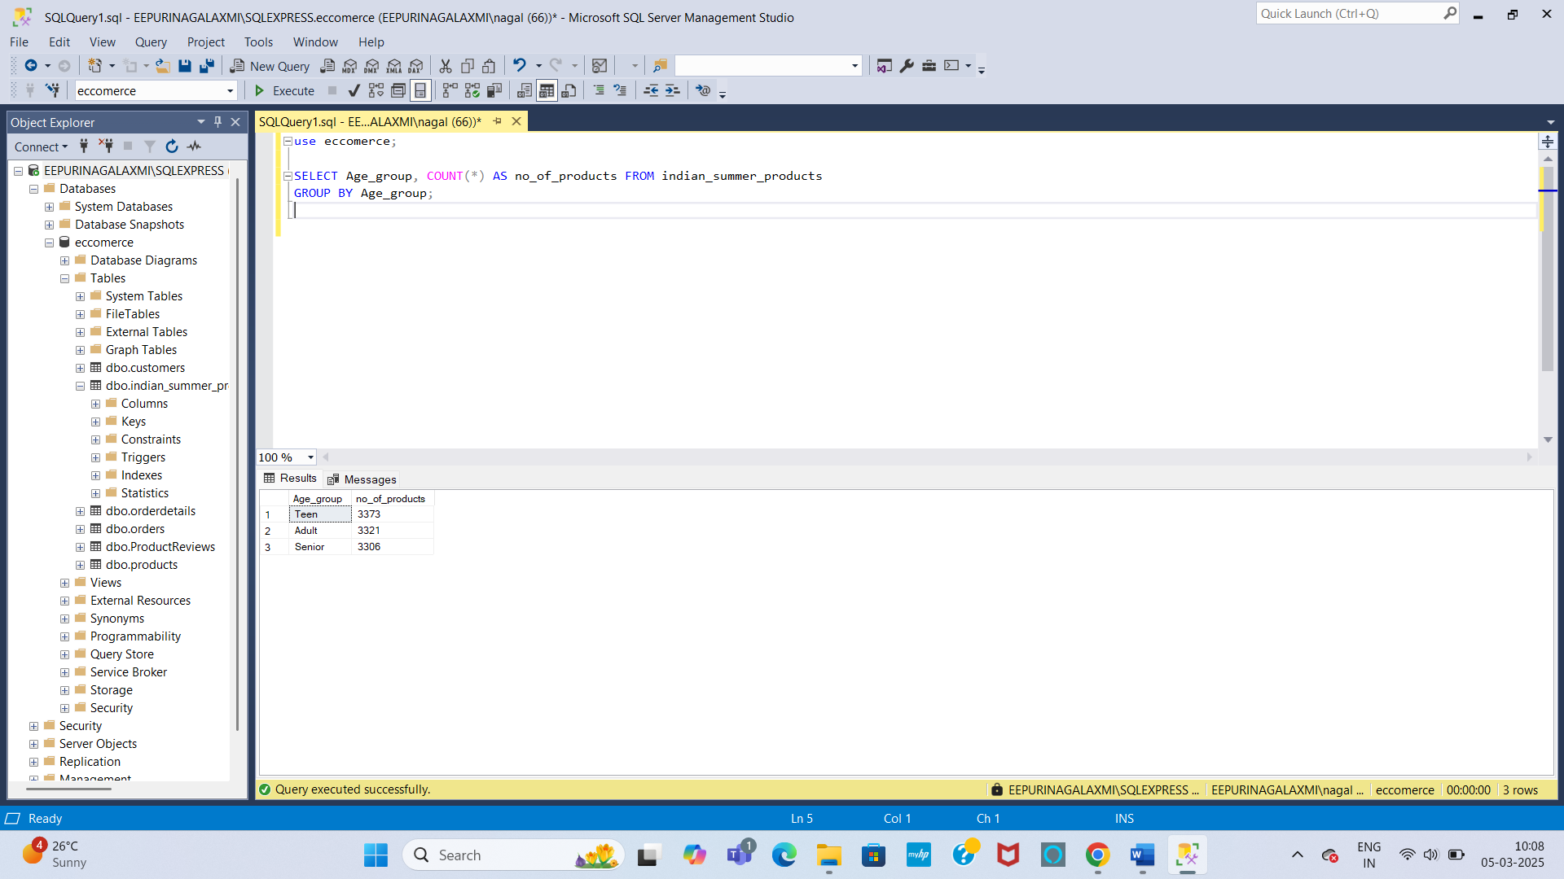

**15. Join the SummerProducts table with ProductReviews and get products with an average Review_Score above 4.5.**

SELECT p.product_id, p.product_name, AVG(r.review_score) AS avg_review_score FROM indian_summer_products p

JOIN ProductReviews r ON p.product_id = r.product_id

GROUP BY p.Product_ID, p.product_name

HAVING AVG(r.review_score) > 4.5;

**Output:**

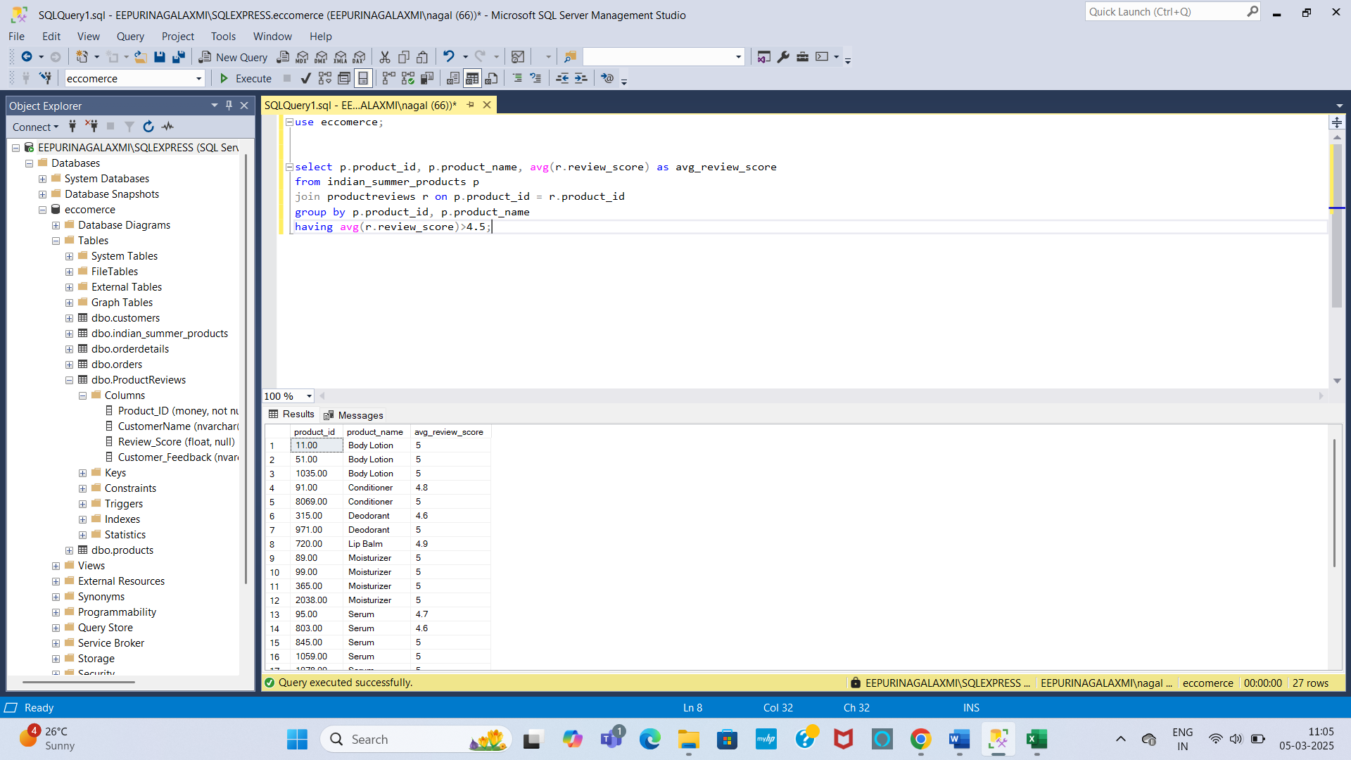

**16. Find all products that have never been reviewed.**

SELECT p.Product_ID, p.product_name FROM indian_summer_products p

LEFT JOIN productreviews r ON p.product_id = r.product_id

WHERE r.Product_ID IS NULL;

**Output:**

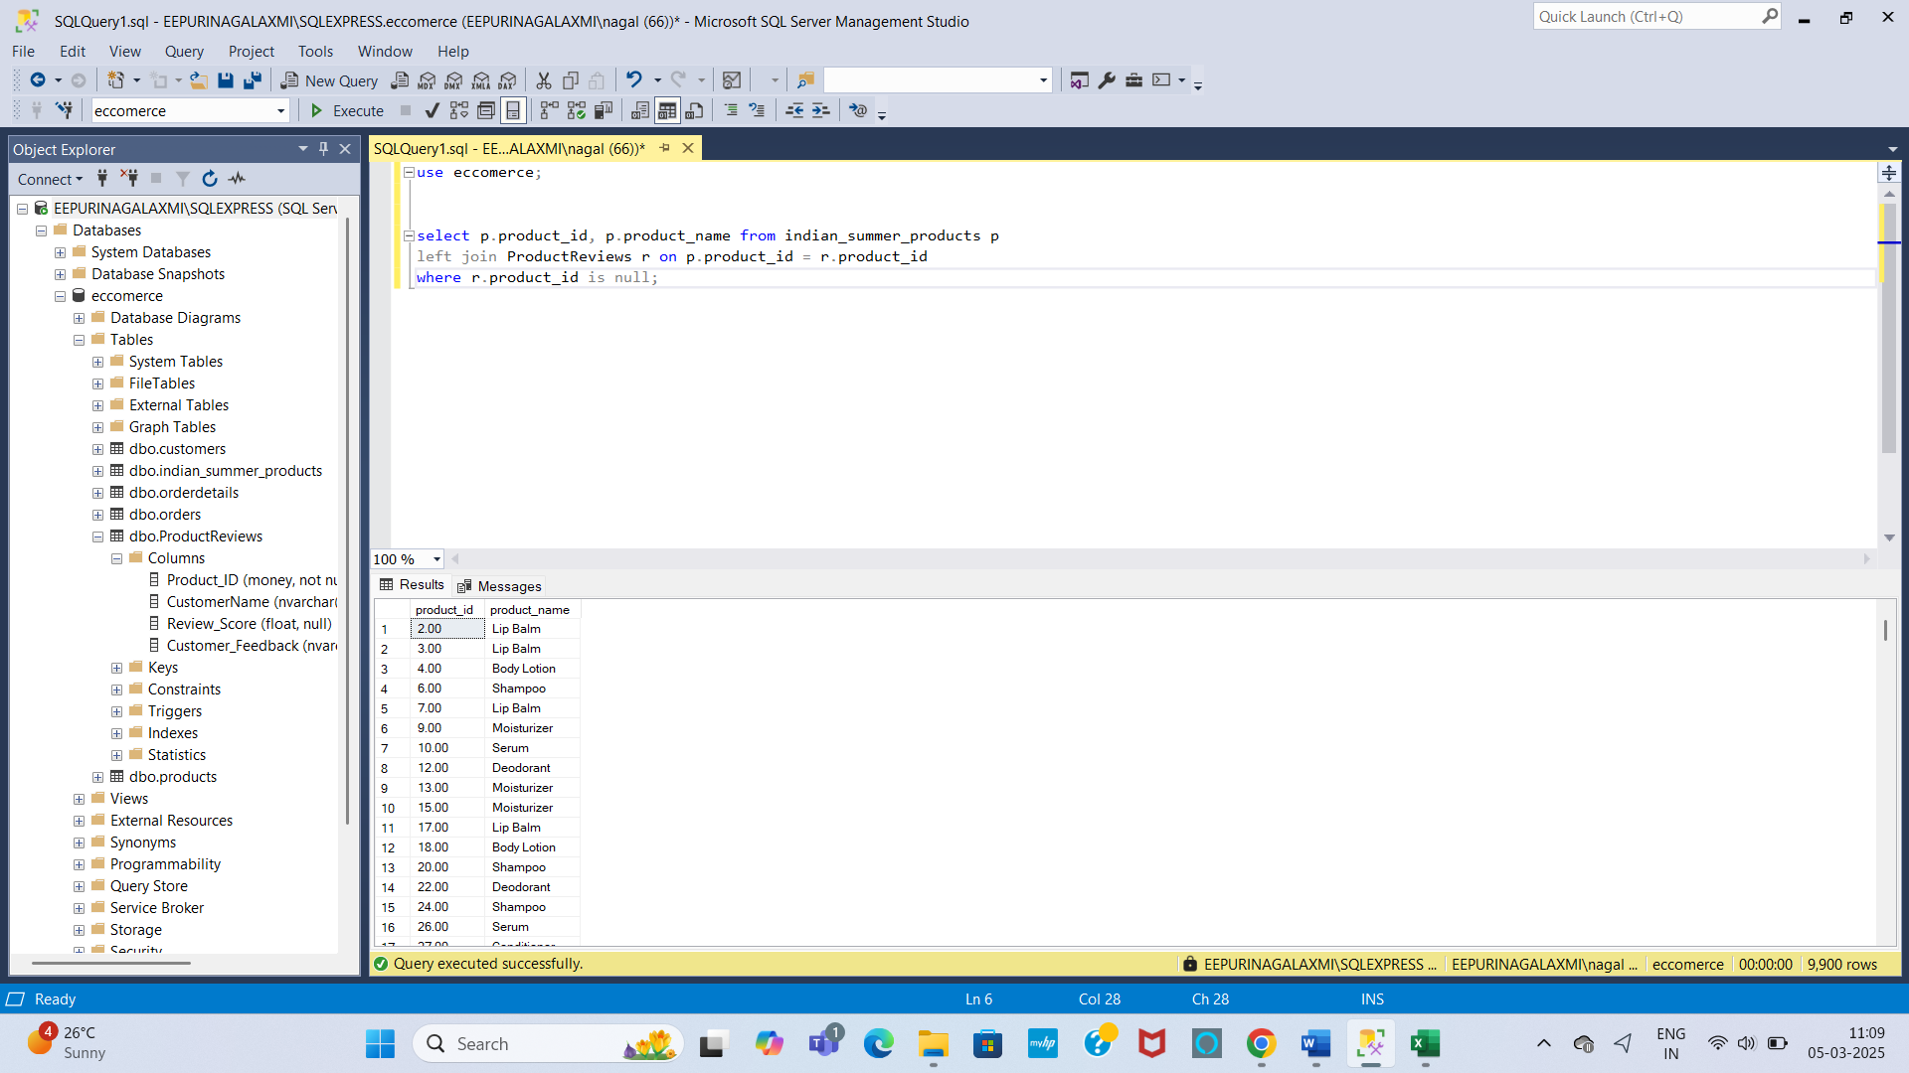

**17. Retrieve all products whose Average_Price is higher than the average price of all products.**

SELECT * FROM indian_summer_products

WHERE average_price > (SELECT AVG(average_price) AS avg_price FROM indian_summer_products);

**Output:**

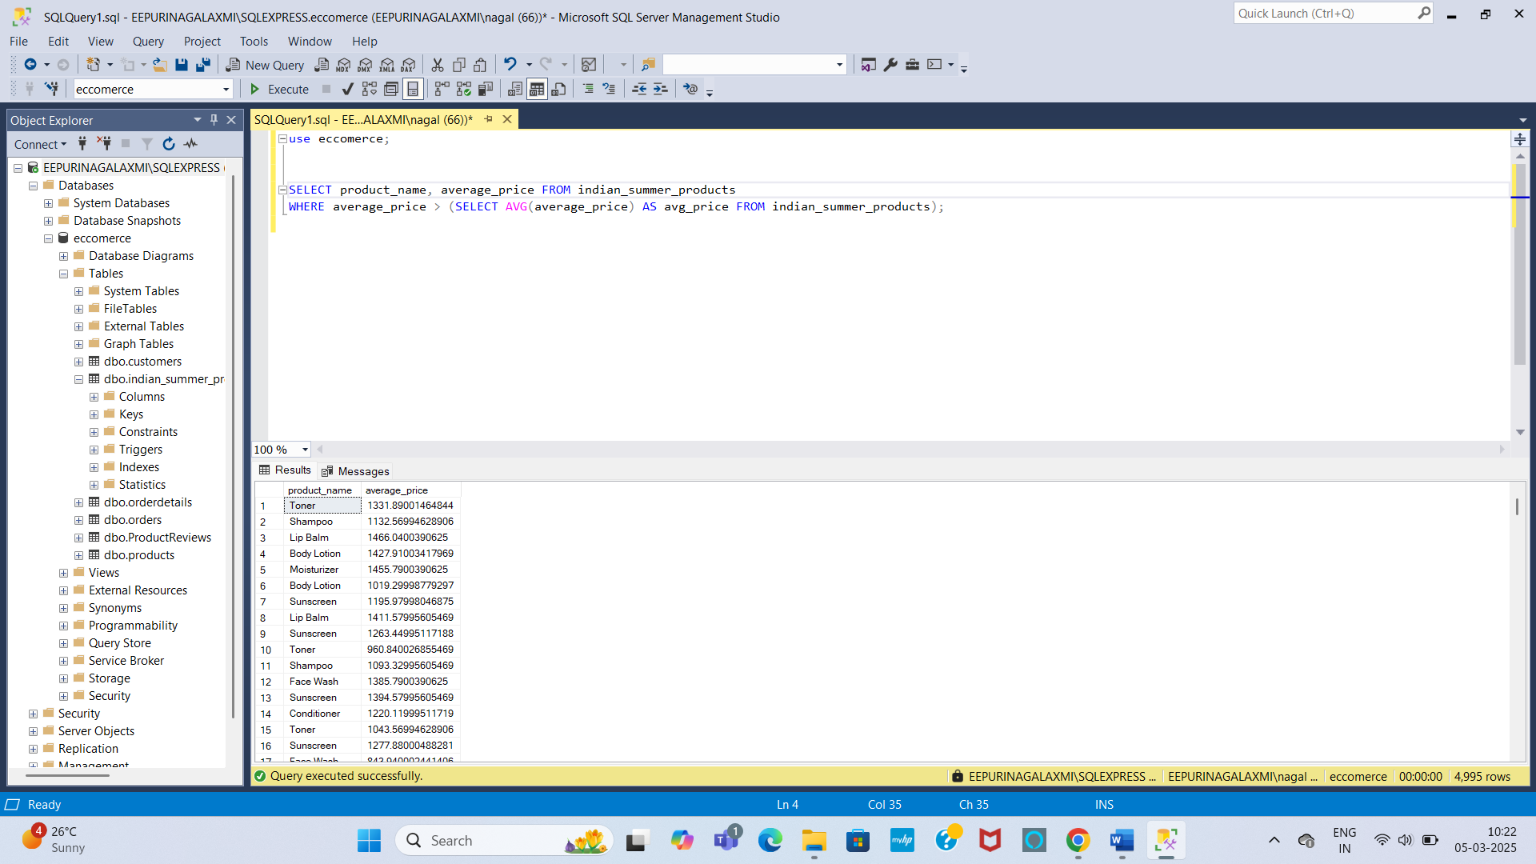

**18. Find the product with the highest SPF_Rating.**

SELECT TOP 1 product_id, product_name, SPF_rating FROM indian_summer_products

ORDER BY SPF_rating DESC;

**Output:**

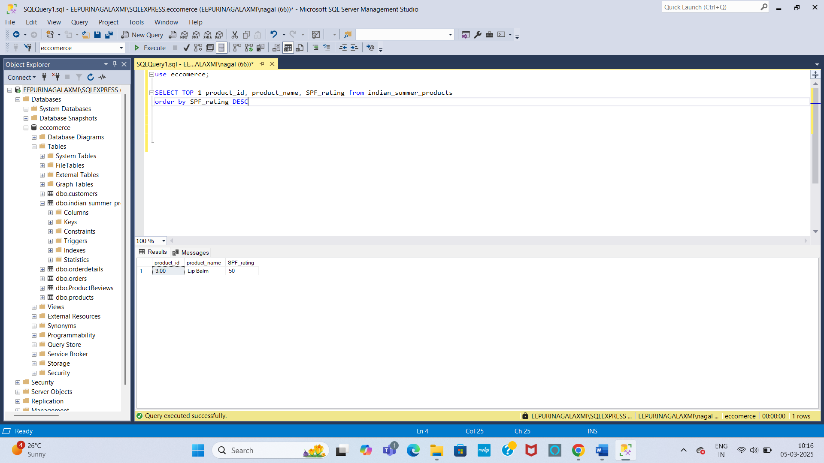

**19. Get products that have the second highest Popularity_Rating.**

SELECT MAX(popularity_rating) second_highest_popularity_rating FROM indian_summer_products

WHERE popularity_rating < (SELECT MAX(popularity_rating) FROM indian_summer_products);

**Output:**

